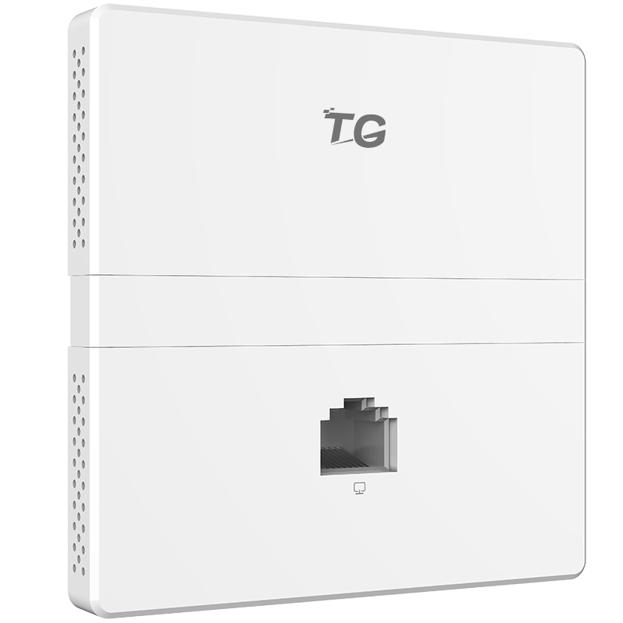

WAP4-300
11n 300Mbps Wireless In-Wall Access Point

Products Description
WAP4-300 is designed to provide wifi for hotel rooms,villa, large apartment etc premise. Adopt of 86 Type wall mount junction box design, it can blend into existing decoration perferctly without any damage. Compliant with PoE 802.3af standard enable it to be deployed quickly. It is easy to setup, manage and monitor with TG AP controller.

Main Features
- High performance panel solutions
The WAP4-300 utilizes Qualcomm's professional chips and excellent hardware configurations to provide a 300M high-performance panel solution for low latency, terminal intensive, and complex applications in commercial WiFi and other scenarios. WAP4-300 supports 802.11b / g / n protocol, 2.4G single frequency dual stream, provides a wider signal coverage, to provide users with high quality Internet experience.
- Beautiful, easy to use
WAP4-300 using standard PoE power supply, can effectively use the hotel's original wiring, do not destroy the original network structure, does not affect the hotel room and other scenes normal operation. Equipment with 86 boxes into the wall design, safe and beautiful. With TG wireless controller, the network maintenance easy and simple.
- Intelligent certification management
The WAP4-300 can meet the different authentication schemes based on SSID. The authentication methods include: authentication-free, one-key authentication, WeChat authentication, SMS authentication, key authentication, built-in account uthentication, Radius authentication, and external server authentication. A wealth of authentication strategies to meet the needs of a variety of user authentication.
- Intelligent seamless roaming and load balancing
Wireless user association WAP4-300, in the wireless signal coverage within the mobile, you can ensure seamless roaming in the two-tier network, and the user in the process of roaming network business is not interrupted. At the same time WAP4-300 support based on the number of users and frequency-based load balancing, when the TG wireless controller found that the AP load exceeds the threshold, if a new user access, TG wireless controller automatically calculated according to the current wireless network environment, the user then access the lighter load AP.
- Local forwarding
WAP4-300 combined with TG wireless controller, open the local forwarding authentication mode, greatly reducing the AC forwarding traffic, ease the AC traffic pressure, AC abnormal downtime in the case will not affect the normal communication of the wireless network.
- Intelligent radio frequency management
The WAP4-300 provides automatic power and channel adjustment. Through the exclusive RF detection and RF management algorithm to optimize the RF coverage effect. When the AP signal is subject to external strong signal interference, through the control AP automatically switch to the appropriate working channel to avoid interference signal to ensure the smooth flow of WLAN communication.
- Plug and play
WAP4-300 work in Fit mode, in the field installation and post-maintenance, AP no need to reconfigure, TG wireless controller quickly find access to the new AP, AP start within 3 seconds to complete the template configuration, TG wireless controller can be issued by a key, AP batch synchronization configuration, greatly reducing the installation, operation and maintenance costs.

Product Specifications
Product Information
Product Model | WAP4-300
Hardware specifications
Fixed port | 2*10/100M RJ45
Maximum Data Rate | 300Mbps
Max Rf Transmit Power | 18dBm
Internal Antennas | Built-in 2 2 * 2 intelligent omnidirectional antenna (gain 3dBi)
Operating frequency band | 802.11b/g/n: 2.4 GHz to 2.483 GHz (China)
Power Consumption | <8W
Dimensions | 86mm×86mm×36mm
PoE | 802.3af power supply supported
Receiver Sensitivity | 802.11n（2.4GHz）
Operating/storage temperature | -10°C~50°C/-35°C~75°C
Operating humidity | 5%~90%(non-condensing)
Ingress Protection Rating | IP41
MTBF | >25000H
Software specifications
System Status | AP Model, AP Name, Up Time, IP&MAC Address, SSID Encryption
VLANs | 802.1Q, 4094 VLAN IDs (1 to 4094) and SSID-based VLAN assignment
Blacklist and whitelist | Static whitelist and blacklist are supported
Wireless Mode | 11b,11g,11b/g,11b/g/n,11n
BSSIDs | 16
Broadcast Storm Suppression | Supported
SSID Hiding | Supported
User Isolation | Supported
Automatic channel control | Supported
Automatic power adjustment | Supported
Clients Limit | Connected user number limitation for every SSID
Bandwidth restriction | STA- or SSID-based rate limiting is supported from AP Controller
Wireless Security | 64/128 WPA-PSK,WPA2-PSK,WPA,WPA2
Authentication mode | authentication-free, one-key authentication, WeChat authentication, SMS authentication, key authentication, built-in account uthentication, Radius authentication, and external server authentication.
Local Forward | Supported
Fat/Fit Mode | Supported
Advanced Settings | Beacon Interval, RTS Threshold, Data Beacon Rate (DTIM),Long/Short Preamble, Short Gi, A-MPDU,A-MSDU,WMM
management | Telnet, HTTP, AP Controller
Access Control | Connect limitation based on mac address
Client Association Status | Supported
Username Management | Supported from Web UI or AP Controller
Firmware Upgrade | Supported from Web UI or AP Controller
Backup & Restore | Supported
Reset/Reboot Device | Supported from Web UI or AP Controller
System Log | Supported
Reboot Schedule | Supported

Order Information
Product Information | Detailed information
WAP4-300 | 2.4G 11n 300Mbps,1 x uplink LAN interface +1 x downlink LAN interface 100M Port, PoE power supply

Shenzhen TG-NET Botone Technology CO. Ltd.
3rd Floor,No.17,Langrong Road, Xinshi Community,Dalang Street,Longhua District,Shenzhen

Website: http://www.tg-net.net
E-mail: cherry.tan@tg-net.cn

